Abraham López

MLK Parade Coordinator Oviedo Citizens In Action, Inc.

P.O. Box 620946

Oviedo, FL 32762

October 14, 2024

Dear Friend of Oviedo Citizens In Action,

Warm greetings from OCIA! As we look forward to the new year, we are excited to extend a heartfelt Invitation to you and your organization to participate in the **2025 Martin Luther King, Jr. Parade and Celebration on Monday, January 20, 2025.**

This year’s theme, **“From Dream to Reality: The Journey Continues,”** reflects Dr. King's enduring legacy and the progress we continue to make toward justice and equality. We welcome participation from businesses, schools, nonprofits, houses of worship, and civic groups to join us in honoring his vision.

The parade will kick off at 10:00 AM at Oviedo High School and will conclude at Center Lake Park, where our Fun Day at the Park celebration will begin at 11:00 AM. Expect a day filled with community, entertainment, and inspiration!

While there’s no entry fee, your generous donations help us create a memorable event for all. Enclosed, you will find the 2025 Parade Packet, including guidelines, the application form, and information on nominating individuals for the I Have A Dream Award. Please submit your application on or before Monday, January 8, 2025.

Once your application is received, a confirmation packet with line-up time and route details will be emailed to you. Should you have any questions, feel free to reach out to me directly at 201-892-6371 or abrahamlopez2@gmail.com.

We look forward to marching with you as we continue the journey toward making Dr. King's dream a reality. Your presence is vital to the success of this event, and we’re excited to showcase the strength and unity of our community together.

Thank you for your support, and we can’t wait to celebrate with you at the 2025 Martin Luther King, Jr. Parade and Celebration!

Sincerely,

**Abraham López**

Parade Coordinator

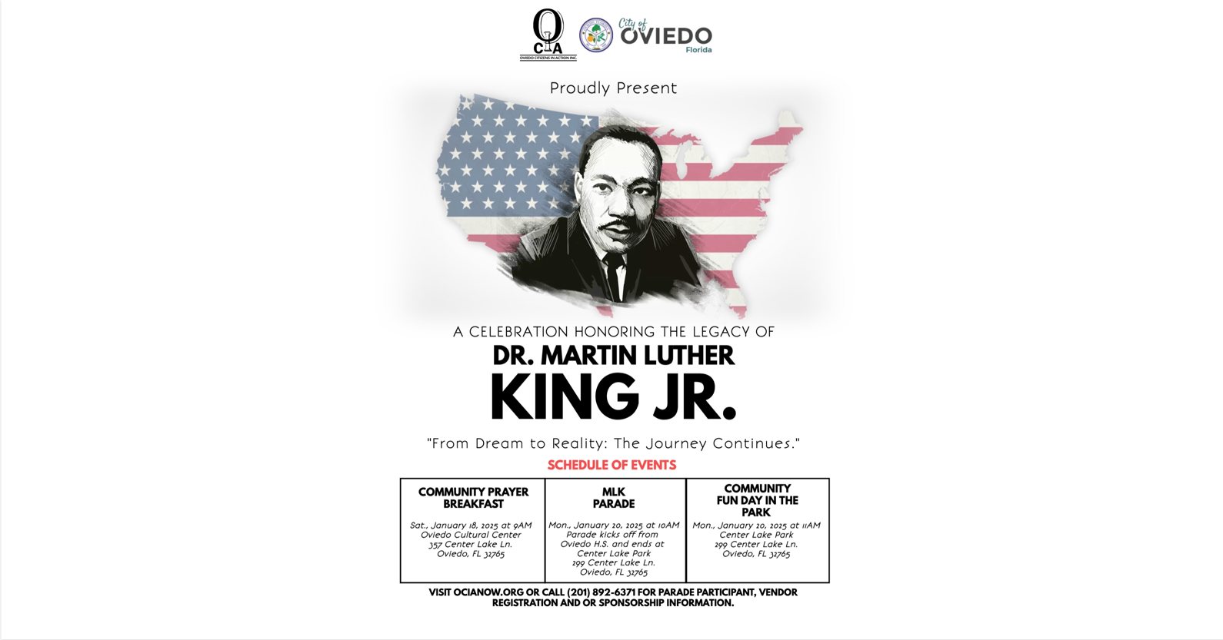

# Parade Guidelines

1. One application per entry must be submitted to participate in the parade.
2. All entries must display a sign, banner or some other insignia promoting the theme of the parade. Entries are prohibited from exclusively promoting an individual business or organization. Presentations with audio and or other visual aids of entertaining/educational value are strongly encouraged.
3. Parade facilitators will guide the movement of the parade. Failure to comply with the parade facilitators’ request could result in that entry’s removal from the parade.
4. An assigned walking parade participant(s) may hand individually wrapped candy or items to the public along the parade route, as it is the preferred way. Items thrown from vehicles or floats must be done low to the ground and away from the street.
5. OCIA will not be held liable for damages or injury because of your participation in the parade.
6. Displaying, dispensing or consumption of any alcoholic beverage is prohibited.
7. All entries and participants shall maintain behavior and safety and perform in good taste from formation and through the duration of the parade.
8. All floats must stop in front of the judges’ stand for 60 seconds for judging.
9. An award for “Best Float”, 1st, 2nd & 3rd place will be given at the “Fun Day in the Park”

# “From Dream to Reality: The Journey Continues”

**Monday, January 20, 2025 Oviedo, FL**

**2025 DR. MARTIN LUTHER KING, JR. COMMEMORATIVE PARADE APPLICATION**

Company/ Organization Name: Address: City State Zip Code

Contact Person: Title Phone: Fax E-mail Address: Authorized Signature:

Type of Parade Unit: (please check one) Float Marching Unit Decorated Vehicle other

Describe Parade entry

***(Size, color, length, number of members, general background information)*** Your position in the parade line up will be decided by the Parade Coordinators and will be given out at parade check-in on the morning of January 20th. The deadline for parade applications is **January 8, 2025.** When your application is received, you will be emailed a confirmation packet that will include the line-up time and the parade route. **The parade will be on January 20, 2025, at 10AM.**

* There is **no** entry fee for this parade, however, donations are welcomed.
* I acknowledge by my signature above that I have received, read and understand the parade’s guidelines attached for the 2025 Dr. Martin Luther King, Jr. Parade.
* As the authorized agent for the sponsor organization, I will decorate my entry to promote the celebration’s theme or Dr. King and not just the name of your business or organization.
* If you plan to enter more than one (1) unit in the parade, please complete a separate application for each unit. Please feel free to make a copy of the attached application.

Thank you for participating in the 2025 Dr. Martin Luther King, Jr. Celebration! If you require additional information, please contact Abe López, Parade Coordinator at 201-892-6371. Email applications to [abrahamlopez2@gmail.com](mailto:abrahamlopez2@gmail.com) or mail to: OCIA at PO Box 620946 Oviedo, FL 32765